INCIDENT REPORTING AND INVESTIGATION ATTACHMENT 1
SECTION 3 Framework for Health and Safety Management

HEALTH, SAFETY INCIDENT REPORT FORM

Incident Outcome and Classification: (circle one from each row, the incident – including Near Miss, must be rated by the ‘maximum credible potential’, not absolute worst case)
ATTACHMENT

Actual (A) | 1A | 2A | 3A | 4A
Potential (P) | 1P | 2P | 3P | 4P
Injury Outcome: | First Aid | MTI | LTI | Near Miss

Date | Time (am/pm)
Exact Incident Location
Process/Task Description
Incident Description (Describe what happened – facts only. Attach additional pages if required)
Immediate Actions Taken (Describe what immediate actions were taken – include medical treatment)
Plant/Equipment Involved
Name of person(s) involved in incident/ accident | Worker Type (tick) |  | Name(s) | Job Title/Function
 | □ Employee | □ Contractor  Company Name
Additional Injured Employee(s)
Witness Name(s)

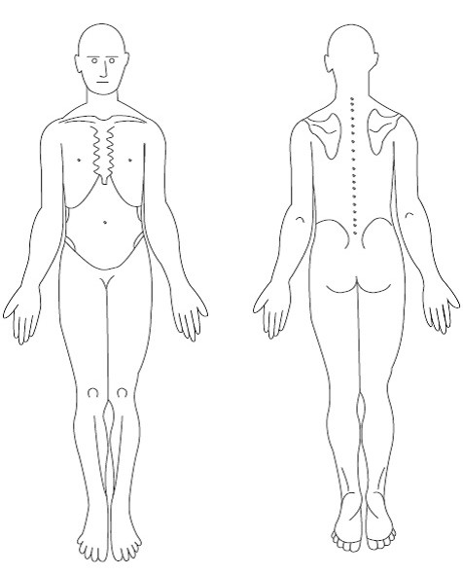
External Medical (tick and provide details as necessary such as GP visit, specialist, x-ray, scan, ECG, physio etc.)
Treatment Provided □ Yes / □ No
SECTION 3 Framework for Health and Safety Management

Record personal details and mark position on body of any injury and first aid:
Date of Birth
Contact Phone #
Length of Employment
Hours worked prior to incident
ATTACHMENT
- Day
Shift
- Afternoon
- Night

Injury Type
(cut/internal/sprain)

Ensure completed forms are handed to HS Team within 24 hrs. Serious injuries to be notified to manager immediately.

COMPLETED BY:
Name |  | Date
Signature
Position |  | Employer
External Notification Reqd?  □ Yes / □ No | Relevant Authority Notified?  □ Yes / □ No | Other? ………….....…….

