ANNUAL HEALTH SAFETY AUDIT PROGRAM PROCEDURE

PURPOSE

To provide an outline for the establishment and management of health and safety audit programs. This includes audits of both management system content as well as operational activities.

DEVELOPMENT OF ANNUAL HEALTH AND SAFETY AUDIT SCHEDULE

SCOPE OF SCHEDULE

The Health and Safety Manager (or equivalent) shall develop an annual health and safety audit program, which shall be referenced in the audit section of the annual health and safety management plan. The audit shall apply to all work locations and activities undertaken by employees and contractors.

MANAGEMENT SYSTEM AUDITS

The Health and Safety Manager shall complete an audit of one of the twelve elements of the AS4801 Management System Standard per month as part of the annual audit program.

The order of elements can be scheduled/adapted to reflect any areas of concern, or recently implemented risk control measures. An audit tool to complete management system audits in line with AS 4801 is provided as attachment one (1) to this procedure.

Sample Monthly AS 4801 Element Audit Schedule
AS 4801 ELEMENT | MONTH
Leadership, commitment and accountability | July
Planning, objectives and targets | August
Legal compliance and system documentation | September
Training and competency | October
Consultation, communication and engagement | November
Risk management | December
Emergency preparedness and response | January
Incident management | February
Monitoring and measurement | March
Health and hygiene control | April
Management system audits, reviews and reporting | May

SITE AND WORKPLACE ACTIVITY AUDITS

The audit program shall contain scheduled audits of workplace activities. These can be scheduled on a monthly basis, to be completed across all relevant workplaces. The annual audit program should be reflective of critical hazards and controls. Relevant audits should be undertaken to assess the effective implementation of changed/modified risk control measures. The annual audit schedule shall include audit of any activities that have had significant corrective actions developed following incidents or previous audit non-conformances.
SECTION 3 Framework for Health and Safety Management
PROCEDURE

The audit tool provided as attachment two (2) to this procedure provides a framework to undertake site/workplace audits relating to the following activities:

General Site inspection

 Suitable for construction activities, or to conduct simple audits relating to the following aspects:

~ Facilities

~ Sub-Contractors

~ Housekeeping

~ PPE Use

~ Excavation & Trenches

~ Formwork & Falsework

~ Welding and Gas Cutting

~ Occupational health

~ Working at Height (includes ladders, EWP, scaffold)

~ Transport & Mobile Plant

~ Equipment and Machinery

~ Cranes and Lifting Equipment

~ Electrical Safety

~ General Traffic Management

CONTRACTOR AUDITS
SECTION 3 Framework for Health and Safety Management

The annual audit schedule shall include audits of contractor activities, in accordance with the Contractor HS Management Procedure. The audits shall include the following elements:

 Assessment of contractors’ compliance to their own management plans and risk control information provided at time of engagement.

 Assessment of contractors’ compliance to the organisation’s health and safety expectations and requirements.
PROCEDURE

Pro-forma audit checklists and tools provided in this and other high risk activity procedures may be used to assess contractor performance and compliance.

CONDUCTING AUDITS

PREPARATION

The auditor must determine who will be involved in the audit and confirm the following with them:

 date, time and venue of audit;

 duration of audit;

 procedure/work instruction/area to be audited;

 scope of audit; and

 previous audit findings.

AUDIT PROCESS

Internal audits are not as formal as external audits. However, the same general process flow is followed. Depending on the scope and nature of the audit the meetings detailed may be adapted and be as formal or as informal as necessary.

Opening Meeting

The auditor briefly introduces themselves and reviews the scope of the audit. If there are a number of auditors and/or auditee involved, a closing meeting may be organised at this time. Any concerns raised by the auditee can be clarified during this meeting.

The Audit

The audit is conducted by a combination of interviews, examination of documents, work practices and arrangements. The objective of the audit is to verify compliance with the relevant procedure, work instruction, regulatory or any other audit requirements.
Audit observations and other comments are made on the audit checklist. Any non-compliances or deficiencies identified during the audit are recorded in the checklist and raised as actions in the facilities corrective action system. Actions should be discussed with the relevant person before they are assigned, to agree due dates and avoid any misinterpretation.

Closing Meeting

A brief meeting may be held by the auditor(s) with the auditee(s) to present the audit observations and non-compliances and allow for final discussion before the audit findings are finalised.

TRAINING AND COMPETENCY OF PEOPLE UNDERTAKING AUDITS

Persons conducting audits should be aware of how to perform an effective audit. This includes:

 planning and preparing for the audit;

 asking questions and obtaining evidence;

 confirming policies and objectives;

 highlighting corrective and preventive actions;

 exchanging ideas for improvement;

 recording and reporting the audit.

New auditors can be inducted through an internal training session run by an experienced auditor (e.g. the Health and Safety Manager) and should have an experienced auditor accompany them during their first audit(s). The Health and Safety Manager maintains a list of available internal auditors.

Where possible, auditors should be chosen from different areas and levels of the organisation to enable exchange of ideas and unbiased views of different areas/procedures.

NON-CONFORMANCES AND CORRECTIVE ACTIONS

Where non-conformances/improvement opportunities are found during the audit there may be opportunity to develop and implement correctives actions at the time of the audit. For example to remove surcharge from the side of an excavation. Such activities shall be recorded on the audit report and/or checklist and provided to the Health and Safety Manager.

Where non-conformances present a significant hazard to workers, the auditor shall, in conjunction with the Health and Safety Manager and relevant operational managers ensure work is stopped until non-conformances are implemented.

Corrective actions arising from the audits shall be recorded.

ATTACHMENTS

Attachment 1: Model AS 4801 Health and Safety management System Audit Tool

Attachment 2: Health and Safety Site Audit Tool
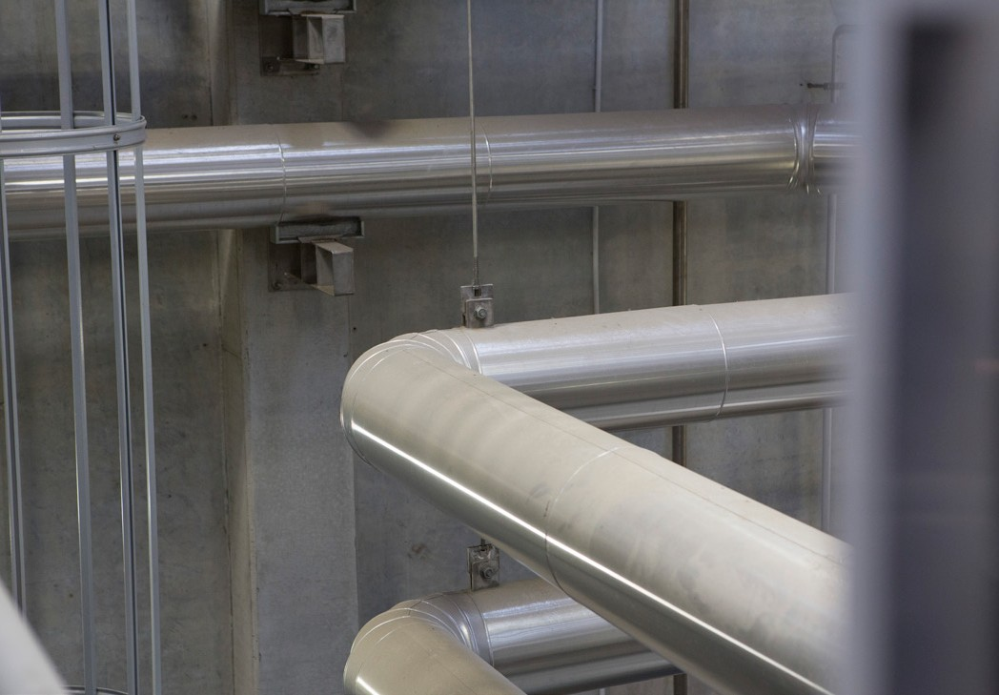
REFERENCES

WATER NEW ZEALAND PROCEDURES & GUIDELINES:
SECTION 3 Framework for Health and Safety Management

Health and Safety Procedures:

 Health and Safety Strategic Management Group Procedure
PROCEDURE

 High Risk Activity Procedures

Health and Safety Guidelines:

 None

LEGISLATION, REGULATION AND STANDARDS

 Health and Safety at Work Act 2015

 Health and Safety at Work (Worker Engagement, Participation and Representation) Regulations 2016

 AS 4801 Occupational Health and Safety Management Systems

 ISO 45001 Health and Safety Management Syste

