SECTION 3 Framework for Health and Safety Management

INCIDENT REPORTING AND INVESTIGATION PROCEDURE

PURPOSE
PROCEDURE
This procedure provides guidance and information to enable the prompt reporting and investigation of health and safety incidents.

GENERAL REQUIREMENTS

INCIDENT REPORTING SCOPE

All health and safety incidents that occur, including near misses, must be reported at the earliest opportunity, immediately where possible.

This includes incidents involving the organisation’s employees and/or contractors working for the organisation.

REPORTING INCIDENTS

All incidents and near misses that cause harm to people or damage to property, or that in different circumstances might have caused harm or damage (near misses), and involve staff, contractors, visitors, consultants or members of the public, are to be reported and investigated to enable action to be taken to prevent any reoccurrence.

Incidents may be initially reported by workers verbally to supervisor or manager, who report the incident verbally to their health and safety manager at the earliest opportunity.

An Incident report must then must completed and forwarded to the health and safety manager within 24 hours. The report shall include:

 Date, location and time of accident

 Name of injured person (if known)

 Names of other witnesses (if known)

 Type of injury

 Part of body injured

 Source or cause of injury

 Any damage to equipment or plant

 What was sited at the event.

A sample health and safety incident report form is provided as Attachment one to this procedure.
SERIOUS INCIDENTS AND NOTIFIABLE EVENTS

In the event of a serious harm incident, or near miss, the responsible supervisor, team leader or manager shall:

 Ensure the relevant emergency services have been called

 Ensure the emergency alarm has been activated as appropriate

 Preserve the incident scene as soon as possible. Only interfere with the incident scene if essential to provide first aid or to prevent the situation from escalating

 Notify the Health and Safety Manager/Team as soon as reasonably practicable to determine if the incident is reportable to WorkSafe NZ as a Notifiable Event

 Follow the steps outlined in the 'Assistance at incident scene' section below

INCIDENT RESPONSE

PROVISION OF FIRST AID

If an incident occurs which requires more than minor attention, then assistance shall be sought from the First Aid certified workers in each location. No matter how minor, details of the injury should be recorded on the Incident Report Form.

ASSISTANCE AT INCIDENT SCENE

Note: It is an offence to interfere with an incident scene where a Notifiable Event has occurred, except in special circumstances as stated in the relevant legislation. The health and safety manager will notify the relevant statutory authority when this is required.

If a worker witness an incident, they should:

 Not put themselves at risk and ensure that nobody else is at risk before attempting to offer assistance

 Warn others of potential danger

 Send for help as soon as possible

 Provide assistance and First Aid within the limits of their ability

 Continue to provide assistance until someone with higher skills can take over.

After assistance has been provided, witnesses recollections should be recorded at the earliest opportunity (while the details are still clear memories) using the Incident Report Form.

INCIDENT INVESTIGATION

The health and safety manager will classify the incident once the report is received. The classification will be for both the actual incident and the potential outcome of the incident. The potential outcome classification shall be used to determine the level of investigation undertaken.

INCIDENT SEVERITY CLASSIFICATION
INCIDENT LEVEL | DEFINITION
1 | Causes (1A) or has the potential (1P) to cause no injury or First Aid Treatment. Incident allows person to carry out normal duties.
2 | Causes (2A) or has the potential (2P) to cause Medical Treatment Injury. Offsite medical treatment that results in no time (shift or day) lost and allows person to return to normal duties.
3 | Causes (3A) or has the potential (3P) to cause Lost Time Injury. Offsite medical treatment that results in time (shift or day) lost before person is able to return to normal duties.
4 | Causes (4A) or has the potential (4P) to cause Serious Injury. Incident which permanently alters the future of the person (fatality, quadriplegia, amputee, disabled back or psychological disturbance).

Actual Consequence: The result of the incident, in terms of HS outcomes for people effected.

Potential Consequence: The “maximum credible” potential, not absolute worst case HS outcome for the people effected.

INCIDENT OUTCOME CLASSIFICATION

The incident report form shall include information about the actual incident injury outcome in accordance with the definitions below:

Restricted work injury: Where an injury prevents a return to work on normal duties for 1 day/shift or more

Lost time injury: Where an injury prevents a return to work for 1 day/shift or more.

Medical treatment Injury: A work-related injury or illness that requires medical treatment, including a patient being managed or cared for by a doctor or health care professional for the purposes of combating disease or injury. The following are not considered medical treatments:
Visits to the doctor or health care professional solely for observation or counselling.

Diagnostic procedures, including administering prescription medications that are being solely used for diagnostic purposes.
SECTION 3 Framework for Health and Safety Management

Any procedure that can be labelled/described as first aid.

First Aid Treatment Injury: Where an incident in first aid treatment being provided and results in no time (shift or day) lost and allows person to return to normal duties.
PROCEDURE

Serious Injury:

A work related injury or illness that requires a person to have:

 Immediate treatment as an in-patient in hospital for more than 24 hours; or

 Immediate treatment for:

~ The amputation of any part of the body

~ A serious head injury, (fractured skull, loss of consciousness, blood clots or damage to face / brain)

~ A serious eye injury (loss, or partial loss of sight, object / substance penetrating eye)

~ A serious burn, requiring intensive or critical care

~ Separation of skin from underlying tissue (de-gloving or scalping)

~ A serious spinal injury

~ Loss of bodily function (loss of consciousness, movement of a limb, sense or function of internal organ)

~ Serious laceration causing permanent impairment

~ Medical treatment for gradual onset of serious occupational related illness or disease.

Near Miss: no injury or illness sustained form the incident.

INVESTIGATION METHODOLOGIES
SECTION 3 Framework for Health and Safety Management

Incidents with a Level 1 and Level 2 classification shall be investigated using a standard methodology, such as 5 Whys incident investigation process, or WorkSafe Duty Holder Review. http://www.worksafe.govt.nz/worksafe/toolshed/duty-holder- review/duty-holder-review-information-sheet

Incidents with a level 3 or 4 classification shall be investigated using a standard methodology such as Incident Causation and Analysis Method (ICAM), “Root Cause Failure Analysis”, and may also include WorkSafe Duty Holder Review. Health and Safety consultants or professional bodies such as the New Zealand Institute of Safety Management will be able to provide information about these incident investigation methodologies.
PROCEDURE

Organisations that utilise proprietary incident reporting and investigation systems, (for example Vault) will be required to follow established workflows and processes within these systems. It is recommended that a stand-alone investigation using the methodologies detailed above is completed for level 3 and 4 incidents, if the proprietary system does not include tools that provide the depth and level of investigation afforded by processes such as ICAM.

Investigations shall be conducted with representatives from affected work areas. The Health and Safety Manager shall ensure that investigation teams are led by suitable trained and experienced people and include people with the relevant knowledge relating to the activity, process, plant or equipment involved in the incident.

CORRECTIVE ACTIONS

The purpose of defining and implementing corrective and preventative actions is to ensure that incidents do not re-occur. Corrective actions shall be developed to manage the level of risk as low as reasonably practicable.

That is controls that reduce risks to levels that are “acceptable and cannot be reduced further without time, money or effort that is disproportionate to the benefit gained or where the solution is impracticable to implement”.

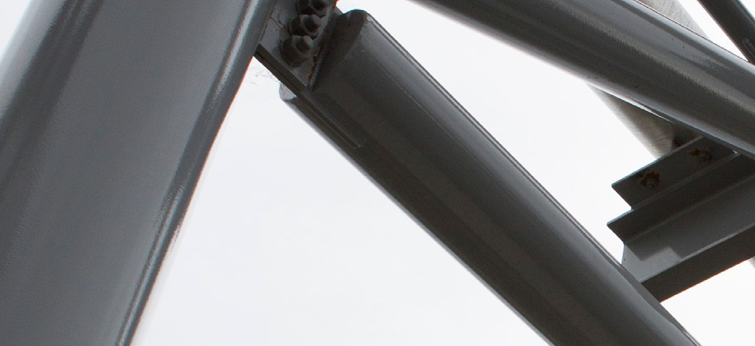
IDENTIFICATION OF CORRECTIVE ACTIONS

Corrective actions shall be determined for all identified causal factors. They must address all causal factors identified during the investigation processes.

Corrective actions shall be identified by the investigation team, in conjunction with representative from the workgroups, or workers effected by their implementation.

The hierarchy of controls should be used when considering and identifying corrective actions that may be put in place. More effective controls, such as elimination or engineering controls must be applied where reasonably practicable, rather than immediately using lower level controls, such as PPE.

COMMUNICATION AND CONSULTATION

The Health and Safety Manager shall ensure that proposed and planned corrective actions resulting from incidents are communicated back to workers. This can be done via established methods such as; Committee Meetings, Weekly Toolbox Talks, Alerts, Daily Briefings or team meetings.

Consultation shall be undertaken to ensure that proposed corrective actions do not inadvertently introduce additional hazards into the work place and that worksites have sufficient understanding of requirements and adequate notice to make required changes to the physical layout of sites, work practices or procedures.

