SECTION 3 Framework for Health and Safety Management

PERFORMANCE REPORTING PROCEDURE

PURPOSE

This procedure provides guidance and information to enable organisations to develop and provide regular health and safety performance reports. Performance reports are made available to workers and management, as well as external stakeholders where required.

GENERAL REQUIREMENTS

The organisation will develop and provide performance reports to enable effective tracking of performance and input to industry benchmarking.

SELECTION OF PERFORMANCE MEASURES

A standard performance report has been developed by the Zero Harm Business Leaders Forum. This requires that developed by the Zero Harm Business Leaders Forum. Organisations shall
capture and report on the lag performance metrics shown in Table 1 below.

Organisations may develop additional performance measures and indicators to suit their own needs or requirements, some examples of additional performance indicators are provided in Table 2.
PROCEDURE
There should be a balance of lead and lag performance indicators to enable effective understanding of organisational performance and trends that may impact health and safety outcomes.
Lead indicators should seek to measure both behavioural and management system aspects and elements. Organisations may developed mechanisms to capture and measure data for performance measures as required.

Definitions for incident types are provided in the Health and Safety Incident Reporting procedure.

Table 1 Core Health and Safety Metrics

MEASURE | HOW TO REPORT REPORTING FREQUENCY
Near Miss |  Year to date, cumulative number of reported near misses.   Near Miss Frequency Rate (NMFR), i.e. the number of reported near misses multiplied by 200,000 divided by total hours worked in the period. | Maintain a 12 monthly rolling NMFR that is reported monthly via performance report.  Calculate annual NMFR at end of organisations reporting period for the year.
First Aid Injury (FAI) |  Year to date, cumulative number of reported first aid treatment incidents.   First Aid Injury Frequency Rate (FAIFR), i.e. the number of reported first aid treatment incidents multiplied by 200,000 divided by total hours worked in the period. | Maintain a 12 monthly rolling FAIFR that is reported monthly via performance report.  Calculate annual FAIFR at end of organisations reporting period for the year.
Medical Treatment Injury (MTI) |  Year to date, cumulative number of reported first aid treatment incidents.   Medical Treatment Injury Frequency Rate (MTIFR), i.e. the number of reported medical treatment incidents multiplied by 200,000 divided by total hours worked in the period. | Maintain a 12 monthly rolling MTIFR that is reported monthly via performance report.  Calculate annual MTIFR at end of organisations reporting period for the year.
Restricted Work Injury (RWI) |  Year to date, cumulative number of reported Restricted Work Injury incidents.   Restricted Work Injury Frequency Rate (RWIFR), i.e. the number of reported medical treatment incidents multiplied by 200,000 divided by total hours worked in the period. | Maintain a 12 monthly rolling RWIFR that is reported monthly via performance report.  Calculate annual RWIFR at end of organisations reporting period for the year.
Lost Time Injury (LTI) |  Year to date, cumulative number of reported Lost Time Injury incidents.   Lost Time Injury Frequency Rate (LTIFR), i.e. the number of reported medical treatment incidents multiplied by 200,000 divided by total hours worked in the period. | Maintain a 12 monthly rolling LTIFR that is reported monthly via performance report.  Calculate annual LTIFR at end of organisations reporting period for the year.

SECTION 3 Framework for Health and Safety Management

MEASURE | HOW TO REPORT REPORTING FREQUENCY
Total Recordable Injury |  Year to date, cumulative number of reported incidents involving any form of injury or treatment. This includes FAI, MTI, RWI and LTI incidents.   Total Recordable Injury Frequency Rate (TRIFR), the number of reported injury and treatment incidents multiplied by 200,000 divided by total hours worked in the period. | Maintain a 12 monthly rolling TRIFR that is reported monthly via performance report.  Calculate annual TRIFR at end of organisations reporting period for the year.
Days Lost – Lost Time Injuries |  Year to date, cumulative number of days lost by workers who have sustained lost time injury incidents. | Calculate annual number of total days lost due to lost time injuries at end of organisations reporting period for the year.
Days Lost – Restricted Work Injuries |  Year to date, cumulative number of days lost by workers who have sustained restrictive work injury incidents. | Calculate annual number of total days lost due to restrictive work injuries at end of organisations reporting period for the year.

Table 2 Potential Lead Performance Indicators
PROCEDURE

POSITIVE PERFORMANCE INDICATOR | DESCRIPTION
Management Health and Safety Inspections and Site Activities. | May include site inspections, audits, participation in toolbox talks, or HS briefings.
Procedures and management system content reviewed in accordance with schedule or other triggers. | Organisation should maintain an audit schedule of procedures and management system (refer to Water New Zealand Health and Safety Audit Procedures) that can be reported against as positive performance indicator. i.e. % of audits completed in line with schedule.
All position descriptions contain specific health and safety requirements and accountabilities. | Review current position/job description documents and ensure they contain information that is reflective of the organisation’s management system requirements and any requirements of specific procedures.
Close out of corrective actions arising from incidents and audit recommendations. | The corrective action register should contain details on identified corrective actions from incident investigations, inspections, audits and other sources. A performance indicator can be developed based on a completion of actions in line with required time frames.

A guidance document relating to the development and use of lead performance indicators has been developed by Worksafe New Zealand and can be accessed by the link below:

https://www.worksafe.govt.nz/worksafe/about/what-we-do/the- safety-star-rating-scheme/documents-and-images/example-lead- indicators.pdf

ORGANISATIONAL REPORTING

Periodic performance reports shall be provided by the Health and Safety Manager. It is recommended that these are provided on a monthly basis.

USE AND COMMUNICATION OF REPORTS

INTERNAL REPORTING

Strategic Management Group

The health and safety manager will use the monthly performance reports data to develop an insight report for use by the strategic management group. Details of an insight report and selection of measures that may be incorporated into it are described in the Governance Insight Report attachment to the Health and Safety Strategic Management Group Procedure.

Health and Safety Committees

The Health and Safety Manager will develop the monthly performance report for discussion and review at committee meetings. The report shall include any analysis of data to identify trends in incident factors, positive events or other metrics as required.
SECTION 3 Framework for Health and Safety Management

Copies of health and safety performance reports shall be displayed and made available via noticeboards and the organisation’s intranet.
PROCEDURE

EXTERNAL REPORTING

The Health and Safety Manager shall develop health and safety statistics and information for inclusion in the organisation’s annual report.

In specific situation’s the organisation may be required to provide health and safety performance reports to regulatory authorities. In such instances the Health and Safety Manager shall develop and provided reports as requested.

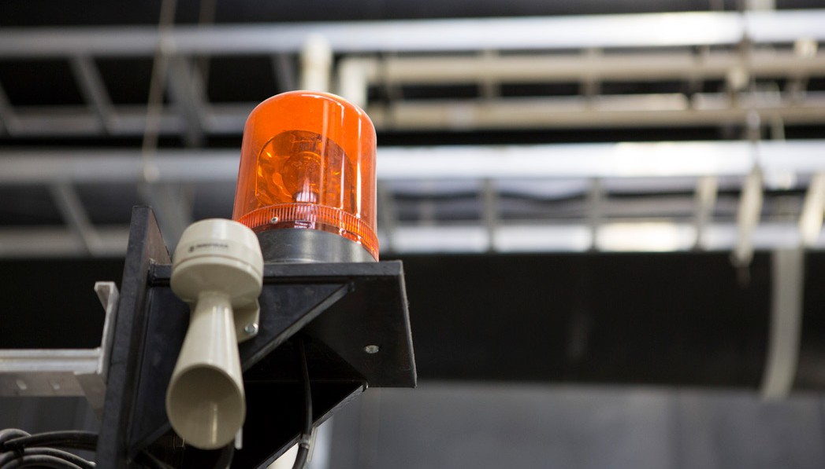

RECORD KEEPING
SECTION 3 Framework for Health and Safety Management

Records of periodic health and safety performance reports shall be retained by the Health and Safety Manager.

TRAINING REQUIREMENTS
PROCEDURE
Persons developing performance reports shall be trained in the use of any relevant in-house or proprietary health and safety data bases and sources.

REFERENCES

WATER NEW ZEALAND PROCEDURES & GUIDELINES:

Health and Safety Procedures:

 Incident Reporting and Investigation

 Annual Health and Safety Audit Program

 Health and Safety Management Plans

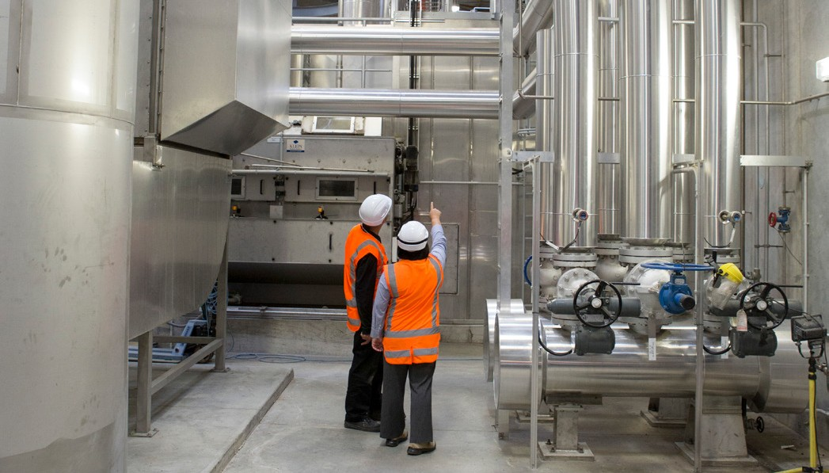
LEGISLATION, REGULATION AND STANDARDS

 Health and Safety at Work Act 2015

 Health and Safety in Employment Regulations 1995

 AS 1885.1 - 1990 Measurement of Occupational Health and Safety Performance

OTHER GUIDELINES:

Monitoring what matters: Sample Health and Safety Performance Reports http://www.zeroharm.org.nz/assets/docs/our-work/ monitoring/Monitoring-what-matters.pd

