SECTION 4 Operational Procedures and Guidelines

ASBESTOS MANAGEMENT

The scope of the Asbestos Management procedure contained in this section of the guidelines covers asbestos material NOT associated with pipes
or pipelines, i.e. asbestos material present in buildings, for example roof sheets, switchboards.

Organisations should refer to the industry “Water New Zealand, National Asbestos Cement Pressure Pipe Manual: Volume 1” for health and safety requirements when working with asbestos material containing pipes. This would include work practices associated with cutting into, removal, storage or replacement of ACM pipes.
PROCEDURE

PURPOSE

To ensure that workers are aware of the requirements for control of Health and Safety Risks associated with Asbestos Containing Materials (ACM).

The requirements of this procedure apply to operational and construction related activities.

Where a contractor has been appointed as Principal to control works on site this procedure shall be adopted as a minimum standard (best practice guidance material) if the Principal Contractor does not have an equivalent procedure.

The users will still need to evaluate and verify all actual conditions (for on-site and off-site works) involving ACM.

ASBESTOS MANAGEMENT PROCESS

ASBESTOS DATABASE

An asbestos database should be maintained at the workplace to identify and management asbestos. The database must record the following:

 All ACM identified at workplaces

 ACM that has been removed from workplaces

 Materials tested and were subsequently found to contain no asbestos

 Certificates of analysis for all asbestos tests undertaken

ASBESTOS REGISTER

An asbestos register must be developed and maintained for all workplaces where ACM has been identified or is assumed to be in the workplace. These registers must be easily accessible to all workers entering or undertaking work at workplaces.

Asbestos registers are to be maintained and reviewed as required by the Health and Safety at Work (Asbestos) Regulations 2016.

ASBESTOS WARNING SIGNS AND LABELS

Where practicable, asbestos warning signs and labels should be installed to ensure that asbestos is not unknowingly disturbed without the appropriate precautions being taken. The presence and location of ACM in the workplace should be confirmed by installing asbestos warning signs at all of the main entrances
to workplace where ACM is present and any areas within a workplace which contains ACM.

Examples of warning signs are shown below.

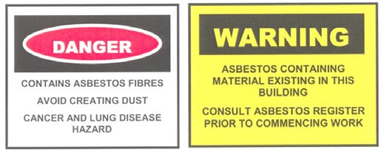

ASBESTOS MANAGEMENT PLAN

Where ACM has been identified within a workplace, an Asbestos Management Plan must be developed, implemented and maintained as required by the Health and Safety at Work (Asbestos) Regulations 2016. This must be monitored in conjunction with relevant operational, maintenance and project delivery stakeholders.

The asbestos management plan will reflect a hierarchy that where possible asbestos will:

 Be left in situ and monitored for ongoing stability and integrity.

 Removed when stability or integrity presents a risk of exposure to ACM by workers.

PERSONAL PROTECTIVE EQUIPMENT (PPE)

In addition to the company minimum requirements for PPE, Masks (P2) may be provided in the event of accidental discovery, however workers should evacuate the immediate area and position themselves upwind of the site.

ACM RELATED WORK

Only appropriately licenced and experienced contractors are permitted to undertake ACM-related work.

DEMOLITION, OR REFURBISHMENT OF STRUCTURES OR PLANT

In accordance with the Health and Safety at Work (Asbestos) Regulations 2016, demolition or refurbishment of structures or plant, including works conducted on utilities infrastructure (not including minor or routine maintenance work or other minor work), the organisation must determine if ACM is present. A licenced and competent assessor should be engaged to accomplish this.

If ACM is found to be present, then an ACM control plan must be included in the Project Management Plan, including plans for the removal of ACM by a licenced and competent removalist, as
required by the Health and Safety at Work (Asbestos) Regulations 2016.

TRAINING

All workers must have the skills and knowledge to understand the hazards associated with exposure to ACM and the risk controls implemented for their protection. All workers must attend an ACM Awareness course. This training should include actions to take in the event of accidental exposure and/or accidental discovery of ACM.

Project/Job Supervisors should undertake ACM management and emergency management training, thus allowing them to respond appropriately in the event that accidental discovery occurs.

At the time of publishing this guideline Worksafe was developing training requirements for asbestos removal work. It is suggested that water supply managers maintain a register of contractors who have received adequate training (in house or otherwise), to conduct work on above or below ground Asbestos Containing Materials.

TRAINING RECORDS

Persons in control of the workplace shall maintain records of ACM Awareness training and other ACM training and make available during audits and inspections.
ACCIDENTAL DISCOVERY

In the event of accidental discovery of ACM, stop work/s immediately. Contact the Project Manager or team leader to activate ACM accidental discovery procedures. Accidental discovery of ACM should also be included in the work method statements/work instructions.
SECTION 4 Operational Procedures and Guidelines

If in doubt treat the product as ACM until identified otherwise.
PROCEDURE

NOTIFIABLE INCIDENT

Any Notifiable Incident as identified by the Health and Safety at Work Act 2015 and the Health and Safety at Work (Asbestos)
Regulation 2016, must be notified within the specified period of time. Incidents will be managed according to the incident management procedures.

PROHIBITED WORK PRACTICES

The following work practices are prohibited due to the risks of ACM exposure:

 Work practices in the vicinity of ACM that may disturb or damage the material, cladding, enclosure, sealant or containment barriers

 Workers using high pressure water process to clean an ACM product or to clean up debris containing ACM

 Workers using compressed air to clean ACM products or a surface where debris containing ACM is present

RECORD KEEPING

All ACM documentation, including ACM Management Plans, incident reports, and ACM testing and removal records shall be retained by and be readily available upon request.

REFERENCES
SECTION 4 Operational Procedures and Guidelines

WATER NEW ZEALAND PROCEDURES & GUIDELINES:

Water New Zealand Asbestos Cement Pipe Manual

Health and Safety Procedures:
PROCEDURE

 Contractor Health and Safety Management

 Hazard Identification, Risk Assessment and Control

 Health and Safety Training Program

 Incident Reporting and Investigation

Health and Safety Guidelines:

 Water New Zealand National Asbestos Cement Pressure Pipe Manual: Volume 1

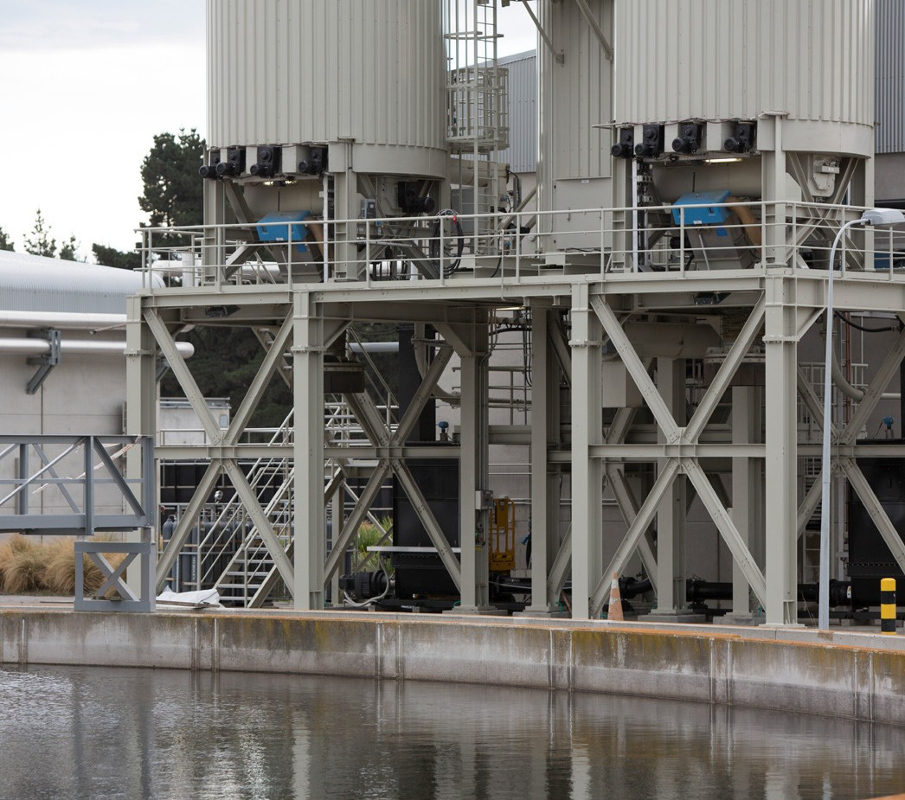
LEGISLATION, REGULATION AND STANDARDS

 Health and Safety at Work Act 2015

 Health and Safety at work (General Risk and Workplace Management) Regulations 2016

 Health and Safety at work (Asbestos) Regulations 2016

 Health and Safety at work (Worker Engagement, Participation and Representation) Regulations 2016

 Approved Codes of Practice - Management and Removal of Asbestos November 2016

 Water NZ National Asbestos Cement Pressure Pipe Manual

