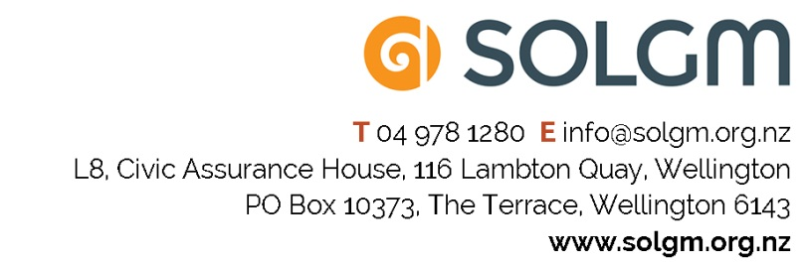

EMBARGOED UNTIL 10.30PM ON 12 APRIL 2018
Southland District Council Engineer wins Local Government Emerging Leader Award
Southland District Council’s Senior Project Engineer for Water and Waste Services, Matt Keil, was awarded local government’s prestigious Brookfields Emerging Leader of Year Award last night at a Gala Dinner held in Auckland.
Also announced at the Dinner, hosted by the NZ Society of Local Government Managers (SOLGM), were seven exceptional and innovative project winners, including a supreme award winner, several overseas exchanges and leadership scholarships, and a management challenge winning team.
Judges praised Matt’s strong leadership attitude, technical expertise, and commitment to engagement.
“Matt stands out through his commitment to making the council water industry accessible and understandable, said Fiona Purchas, SOLGM’s Manager of Professional Development.
“He has led some significant infrastructure projects and has demonstrated a strong commitment to professional development.
The Brookfields Emerging Leader of the Year Award is presented to an emerging leader who has a proven track record of delivering innovative and successful programmes or projects.
The Award, sponsored by Brookfields Lawyers, includes a fully paid trip to attend the ICMA Annual Conference in the US, the largest annual event in the world for local government managers and staff.
“The Gala Dinner is a very special event for the local government sector” says SOLGM’s Chief Executive Karen Thomas.
“It recognises the outstanding contribution and commitment to communities. Throughout New Zealand local government professionals are working on inspiring and collaborative projects and investing in their professional development. We are proud to acknowledge and celebrate this, and the important impact that local government professionals have on the communities we all serve.
“Matt is a well-deserved recipient of this Award, and we are very grateful to Brookfields for their ongoing commitment to partnering with us to recognise excellence in the local government sector.

ENDS
For further information, a full media pack including Council spokespeople, and photos, please contact Ann Thomson, SOLGM, 027 294 3852.

