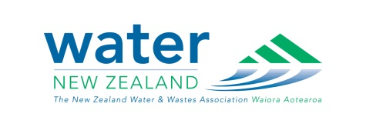

**Water New Zealand’s Modelling Group Auckland Regional Meeting**

**Venue:** Faculty of Engineering Building, Level 4, Room 403.401, 20 Symonds Street

**Date:** Wednesday 8th of June 2016

**Time:** 5.50pm

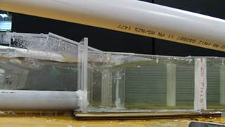**Title:** Physical modelling: On the need for a hydraulic engineering laboratory

**Presenter:** Dr Heide Friedrich

**Abstract:** I will take you on a tour of the diverse physical modelling projects my research group is working on. The projects focus on processes taking place in water-worked environments, such as rivers and oceans: sediment movement/transport and associated flow analysis. Work is taking place in our Hydraulic Engineering Laboratory at the University of Auckland. I will provide my thoughts on where water science/engineering of natural environments takes place, and why physical modelling is making a comeback in recent times. How should you decide if a physical model would be beneficial for your project, and how should you go ahead planning for it.

**Biography:** Dr Heide Friedrich received her undergrad civil engineering degree from TU Berlin, Germany and her postgrad degree from the University of Auckland, New Zealand. She has since been working in hydraulic engineering at the University of Auckland, and leads the Water-worked Environments Research Group ([water.auckland.ac.nz](http://water.auckland.ac.nz/)).

**Mangere Strategic Management Area (SMA) – Wastewater Model Development**

*Or a brief history of wastewater network planning in Auckland*

**Presenters**:

Nicola Haszard, Watercare Services Ltd; Brian Robinson, Delta Water Solutions; Tim Lockie, Watershed Engineering LTd

**Abstract:**

This presentation describes the recently completed Mangere SMA wastewater model analysis. The Mangere SMA covers the reticulated network draining to the Mangere WWTP and is the first time in the region’s history that a comprehensive strategic model has been developed including critical assets from both the transmission and local networks. The SMA model combines a number historic wastewater modelling studies ranging from the Integrated Catchment Study, Project Storm 2, Manukau Water, Waitakere and a number of recently completed detailed studies; to produce a strategic wastewater network model which can be utilised, with certain limitations, to identify network constraints and assess mitigation options to enable growth and meet Watercare’s regulatory requirements. This presentation is a great opportunity to follow the progress of wastewater network planning within the Auckland Region, and how historic investments in modelling studies are still providing value today.